One-Stack Automata

One-Stack Automata are acceptors of Context Free Languages. For example { a^{n}b^{n} : where n > 0 } is a Context Free Language (CFL) which can be accepted by a one-stack automaton. A one-stack automaton is represented visually as a finite set of states connected with transitions.

Example 1: A one-stack automaton for { a^{n}b^{n} : where n > 0 }

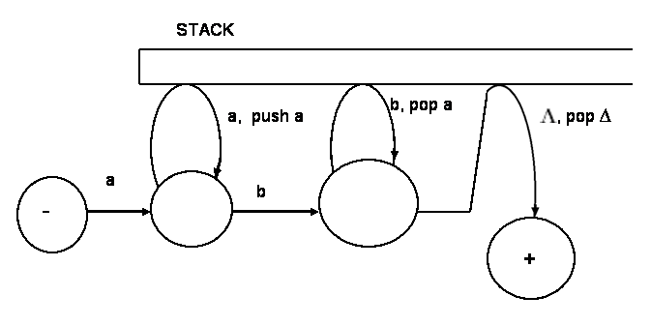

Suppose a string like aabb is given as an input to the above one-stack automaton. Then, the machine starts at the start state and consumes the first a taking the transition marked by a and reaches the next state from where it consumes the second a and pushes an a into the stack taking the transition marked by a, push a. Then it consumes the next symbol, b, by taking the transition marked by b. Next, it consumes the second b, by taking the transition marked by b, pop a and poping a from the stack. Then, it reaches the final state by taking the transition marked by , pop ∆. At that moment, the stack is empty and the entire input is consumed and therefore the input aabb is accepted by the machine. The one-stack automaton given above accepts any string with a sequence of a’s followed by equal number of b’s. That is, strings such as ab, aabb, aaabbb, aaaabbbb, . . . are accepted by the machine.

A DEFINITION OF ONE-STACK AUTOMATA:

A one-stack automaton, abbreviated OSA, is composed of one optional and four required components:

1. Σ : a finite non-empty set of symbols called alphabet from which input strings are formed.

2. S: a finite non-empty set of states including
2a. At least one start state marked by -;
2b. Some (may be none) final states marked by + ;

3. Ω : An optional pushdown STACK, infinite in one direction. Initially, the STACK is empty containing all blanks ( ∆).

4. Г: An optional finite non-empty set of symbols called the STACK SYMBOLS. If the STACK is included then the STACK SYMBOLS are also included.

5. T: A finite set of transitions (edge labels) including:
5a. A finite set of transitions that show how to go from some states to some others, based on reading a specified symbol or a substring from input, possibly even the null string .
5b. Some (may be none) special transitions each of which reads a symbol and inserts a symbol onto the top of the STACK.
5c. Some (may be none) special transitions each of which reads a symbol and pops a symbol from the top of the STACK.
5d. Some (may be none) special transitions each of which examines if the stack is empty by reading and poping ∆.

An input is accepted by an OSA if the following conditions are met simultaneously:
- the input is entirely consumed, that is, no other symbols left in the input;
- the machine is in a final state;
- the stack is empty.

Example 2: A one-stack automaton for { a^{n}cb^{n} : where n >= 0 }

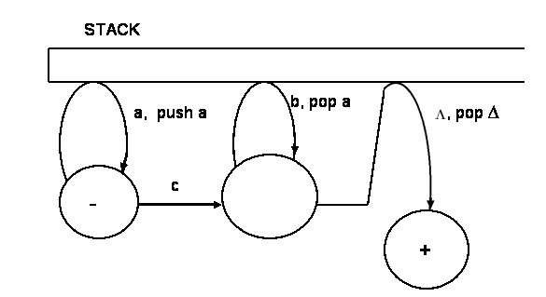

Example 3: A one-stack automaton for { ba^{n}bc*ab^{n} a: where n >= 0 }
