Static Visualization of Turing Machines
Pradip Peter Dey et al
The class of Turing Machines (TMs) is the most powerful class of computing machines. Any problem that can be solved computationally can be solved by a TM. Thus, computability means Turing computability. A TM has a finite set of states with one START state and some HALT states and an infinitely long READ/WRITE tape divided into distinct cells. A TM may not have any HALT state at all and sometimes a TM may have multiple HALT states. The input is initially placed on the tape starting from the leftmost cell. The TAPE HEAD initially points to the leftmost cell. With a given transition, a TM does three things: (1) it reads one symbol from a tape cell, (2) writes one symbol on the same tape cell and (3) moves the TAPE HEAD right or left by one cell. A TM accepts an input string by starting from a start state, moving through a path of transitions and reaching the HALT state. Dynamic visualization of TMs can be seen following the links given at: http://www.asethome.org/automata/. A case of static visualization of a TM is presented below. A finite or infinite set of strings is usually called a language. In this sense a Turing Machine can be viewed as a language processor. We would like to call the following set of strings as Language-1 or L₁.
L₁ = { ab, aba, abaa, abaaa, abaaaa, abaaaaa, . . . }
This language is usually abbreviated as aba* which is a regular expression. The star in this string, after a is known as the Kleene star which means zero or more of a’s. The regular expression aba* means one a followed by one b followed by zero or more a’s. It is perfectly acceptable to write:
L₁ = aba* = { ab, aba, abaa, abaaa, abaaaa, abaaaaa, . . . }

A regular expression such as aba* denoting a set of strings usually represent a pattern in the strings. (Note: If we replace a by N and b by V in this set then we have a pattern NV, NVN, NVNN, which would be a pattern subset from English where N is a Noun and V is a Verb that matches English sentences like “Boys like eggs”, “Boys like eggs, Noodles” . .). The following Turing Machine can process L₁.

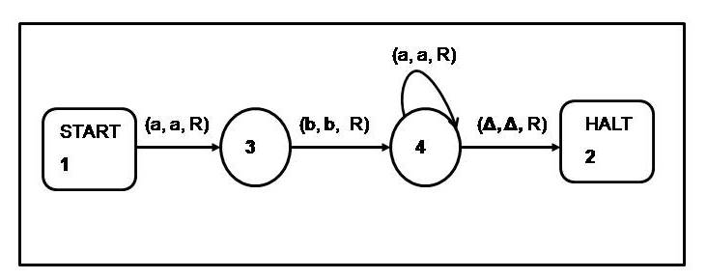
Figure 1: A Turing Machine for aba*
The tape of this Turing Machine is not shown in the diagram; because we do not want to show any specific input on the tape since every string from L₁ is accepted by this machine.
Suppose, as a first experiment, the given input string is abaa, which is a member of the set of strings for which this machine is designed. The machine would look like Figure 2 when the input is placed on the tape.
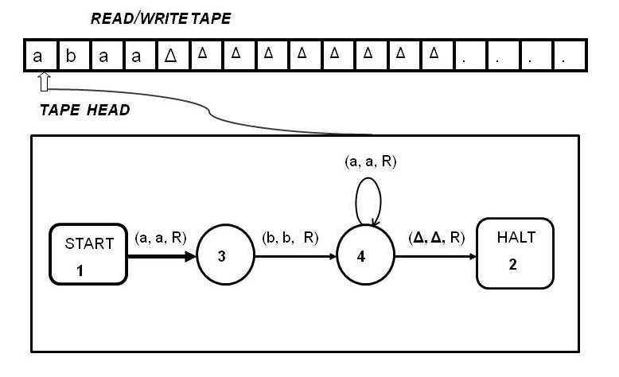
Figure 2: A Turing Machine for aba* with input abaa
The machine, starting from the start state, taking the first transition to state 3, reads the first symbol a from the leftmost cell of the tape writes back a on the same cell and moves right. This is shown in Figure 3.
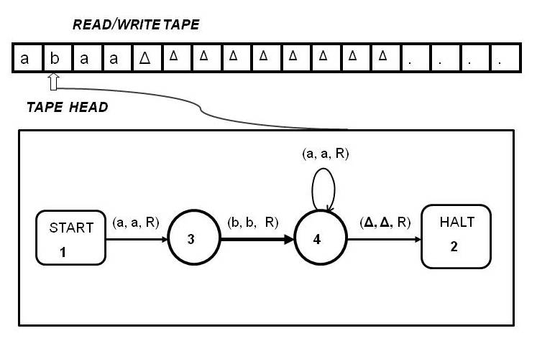
Figure 3: A Turing Machine for aba* which has just scanned the first symbol from the input
Next, the machine, from state 3, taking the transition marked by (b, b, R) reads the symbol b from the second cell of the tape and writes back b on the same cell and moves right on the tape. Taking this transition the machine reaches state 4. The machine configuration is shown in Figure 4.
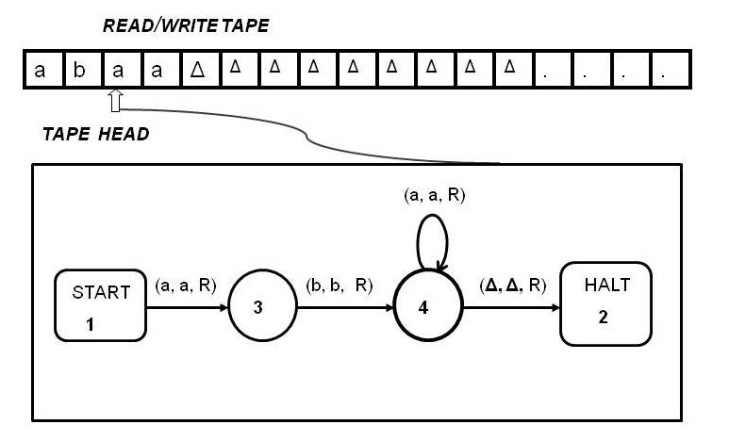
Figure 4: A Turing Machine for aba* which has just scanned 2nd symbol from the input

Next, the machine, from state 4, taking the transition marked by (a, a, R) reads the symbol a from the third cell of the tape and writes back a on the same cell and moves right on the tape. Taking this transition the machine comes back to state 4. The machine configuration is shown in Figure 5.

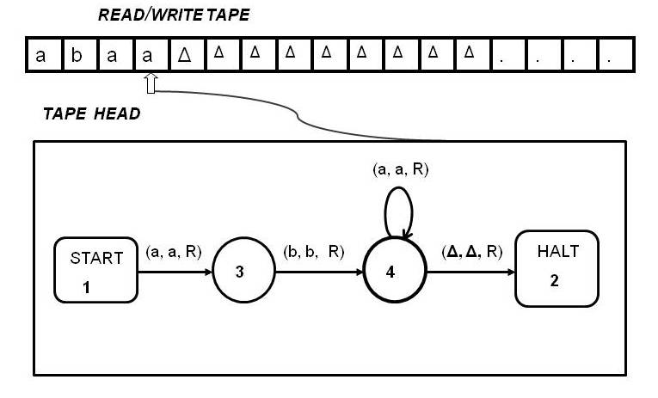

Figure 5. A Turing Machine for aba* which has just scanned the 3rd symbol from the input
Next, the machine, from state 4, taking the transition marked by (a, a, R) reads the symbol a from the fourth cell of the tape and writes back a on the same cell and moves right on the tape. Taking this transition the machine comes back to state 4. The machine configuration is shown in Figure 6.

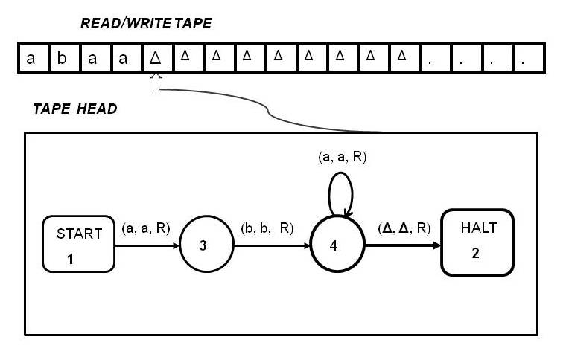
Figure 6. A Turing Machine for aba* which is scanning the null symbol from the tape
In the next step, taking the transition marked by (Δ, Δ, R) from state 4, the machine reads Δ from the fourth cell of the tape, writes back Δ on the same cell and moves right on the tape. Taking this transition the machine reaches the HALT state. The machine accepts the input, abaa, since it reaches the HALT state after traversal of transitions from the start state. The machine configuration is shown in Figure 7.
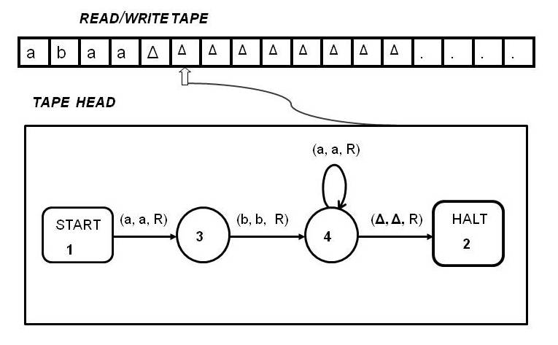
Figure 7. A Turing Machine for aba* which has reached the Halt state and accepted the input

In other words, this machine is designed to accept every string of the set aba* = { ab, aba, abaa, abaaa, abaaaa, abaaaaa, . . . }.

