Post Machines

(Based on Daniel Cohen, (1997), Introduction to Computer Theory , 2nd Edition, John Wiley & Sons.)

In chapter 20 the author describes Post machines. Recall that Emil Post developed a machine for doing computations at the same time that Turing developed the Turing machine. It is interesting to find out how Post's machine works and to learn that the two models are equivalent in computational power.
A Post machine uses a queue for its data structure. Initially the input is located in the queue with the first character of the input at the front of the queue. Each time the machine makes a state transition it reads from the front of the queue and may place characters on the end of the queue if it so chooses.
Imagine how we might use such a machine to recognize strings in the language {a^{n}b^{n} | n 0}. We begin by placing a special marker onto the queue to signify the end of the input. Then we cycle through all the input repeatedly, each time removing one a and one b. After we have run through this cycle n times there should be nothing left but the marker (if the string was properly formed.)
Here is such a Post machine. The labels on the transitions contain the character to be removed from the front of the queue and the character to be placed at the end of the queue.
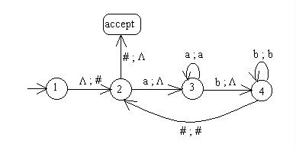
The author proves that these two machines are equivalent in two steps. First he shows that we can use a Turing machine to simulate a Post machine. Then he shows how a Post machine can be used to simulate a Turing machine. We will not do these proofs.
In chapter 21 the author shows that a pushdown automaton with two stacks (a 2PDA) has as much power as a Turing machine. Any language that can be accepted by one can be accepted by the other. This is Minsky's Theorem. We will not go through the details of the proof but it is similar to the previous proof in which the author proves that a Post machine is equivalent to a Turing machine. To prove that a 2PDA is equivalent to a Turing machine we must show how to simulate a 2PDA with a TM and how to simulate a TM with a 2PDA. Since a 2PDA is equivalent to a Turing machine and a Turing machine is the most powerful model of computation, it does no good to add more than two stacks to a pushdown automaton.
In chapter 22 the author studies several variations of the standard Turing machine:
- move-in-state machines
- k tapes, one tape-head machines
- k tapes, k tape-heads machines
- one tape, k tape-heads machines
- machines with 2-way infinite tapes
- nondeterministic machines
All of these machines are equivalent in power to the Turing machine we studied in chapter 19. We shall describe each of them here.
The move-in-state machine does not put the movement of the tape head on the state transitions. It puts the movement in the state. Every time the machine enters a state containing an L, it moves its tape head left, and similarly for states containing R or S. Here is an example of a move-in-state machine. Note that the direction in the start state is not used initially, only on reentry. The machine makes a copy of its input then halts with its tape head on the single blank between the original input and the copy.
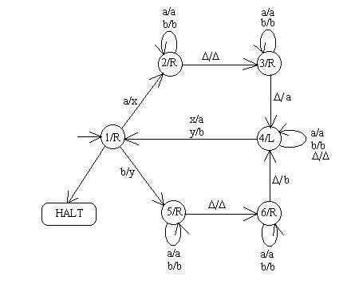
A k-tape machine is a Turing machine with k tapes instead of one. It still has only one tape head but the head can read corresponding cells on all the tapes at once and can write on all of them at once. Another variation is a machine with k tapes and k different tape heads. This machine can have its tape heads in different locations on each tape. We may find it useful to have a machine with only one tape but multiple tape heads. Look in the text at a machine on page 503 that has three tapes and one tape-head. It adds the numbers on tapes 1 and 2 together and writes the answer on tape 3.
A machine with a 2-way infinite tape does not have to prevent its tape head from running off the left end of its tape. Such a machine would be convenient to use to implement an algorithm that adds one to its binary input. Sometimes adding 1 to a binary number means lengthening the number by one digit. If we had room on the left-hand-side of the input we could add the extra digit without having to shift the entire number to the right.
A nondeterministic Turing machine has more than one edge leaving a state with the same first entry in the label. An input string is accepted by a nondeterministic Turing machine if there is some path through the machine that leads to the HALT state on that string. Any language that can be accepted by a nondeterministic Turing machine can be accepted by a deterministic Turing machine. The easiest way to prove this is to show how to implement a machine that tries all possible paths through the nondeterministic machine.
All of these Turing machine variations have the same ability to accept languages. Any language that can be accepted by one type of Turing machine can be accepted by all the others. It is useful to know about these variations, however, because one may be more convenient for a particular algorithm than another and we can feel free to use whichever variation we want.
Other References:
http://www.cs.appstate.edu/~dap/classes/2490/chap20-22.html

