Static Visualization of Pushdown Automata
Pradip Peter Dey and Alireza Farahani
Finite Automata (FA) accept regular languages such as ab* . However, FA are not able to accept Context-Free Languages such as L_{m} = { {^{n}c}^{n} : where n >= 0 }. It is to be noted that L_{m} has strings with matching {'s and }'s separated by a c . What is interesting about L _{m} is that it has a string pattern that is similar (but not exactly the same) to that of programming languages such as Java and C++. In fact, syntactic structures of a programming language are defined by Context-Free Grammars in a way that is similar to that of the Context-Free Grammar (CFG) of L _{m} given below:
S -> {S} | c

This CFG generates or derives a balanced number of {'s and }'s. Pushdown Automata (PDA) are designed to accept languages with strings that have similar patterns. That is, a PDA will accept strings like {c}, {{c}}, {{{c}}}, . . . ., (that is, the strings of L_{m}). PDA use a stack data structure for matching equal number of {'s and }'s without counting them directly. A stack is an interesting data-structure which allows operations such as push and pop and increase or decrease its stored contents in a Last-In-First-Out (LIFO) manner. Stacks are used for processing Context-Free Languages. PDA are described in text-books such as [1] Hopcroft, J., Motwani, R., and Ullman, J. Introduction to Automata Theory, Languages, and Computation, Pearson Education, 2007. [2] Cohen, D., Introduction to Computer Theory, 2nd Edition, New York, NY: John Wiley & Sons, 1997. [3] Lewis, H. R. and Papadimitriou, C. H., Elements of the Theory of Computation, 2nd Edition, New Jersey: Prentice_Hall, 1998.
PDA can be presented in various ways. In the following example, a PDA is presented visually as a finite set of states connected with transitions which is based on the notations of Hopcroft et al 2007 [1] with some minor adjustments.
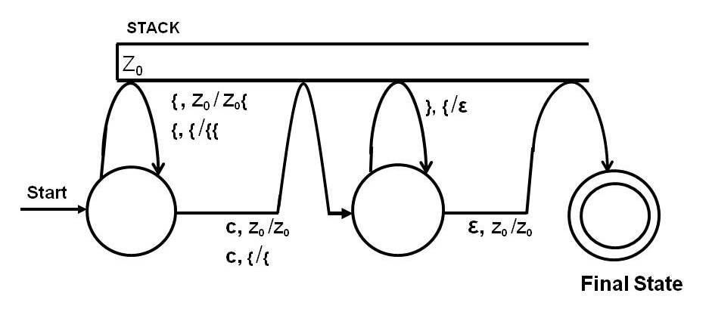
Figure 1: A Pushdown Automaton for L_{m} = { {^{n}c}^{n} : where n >= 0 }.

Suppose, as a first experiment, the given input string is {{c}}, which is a member of the CFL L_{m} = { {^{n}c}^{n} : where n >= 0 }. The PDA would look like Figure 2 when it starts processing the input.
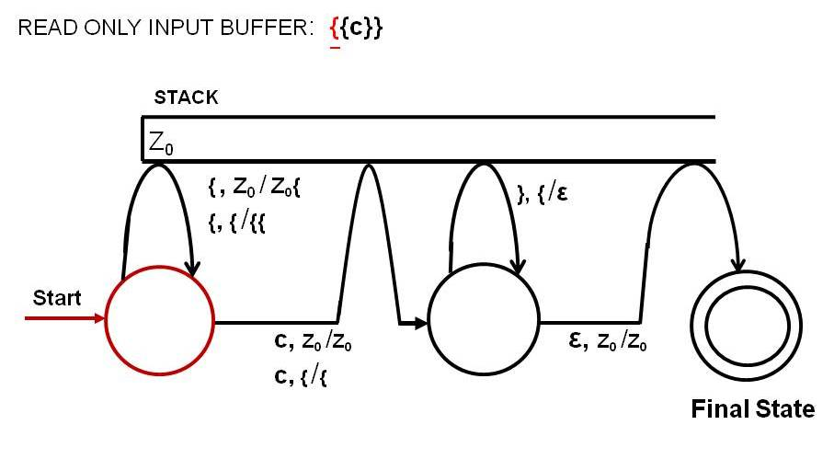
Figure 2: A Pushdown Automaton for L_{m} = { {^{n}c}^{n} : where n >= 0 } which has
started processing the input {{c}}.
The machine starts at the start state and scans the first { from the input and pushes a { into the stack by taking the loop transition marked by, { , Z₀ / Z₀{ . The meaning of this transition label is "when reading a { and the stack is empty (marked by Z₀) push a { onto the empty stack (marked by Z₀)". The PDA in Figure 3 shows this condition.
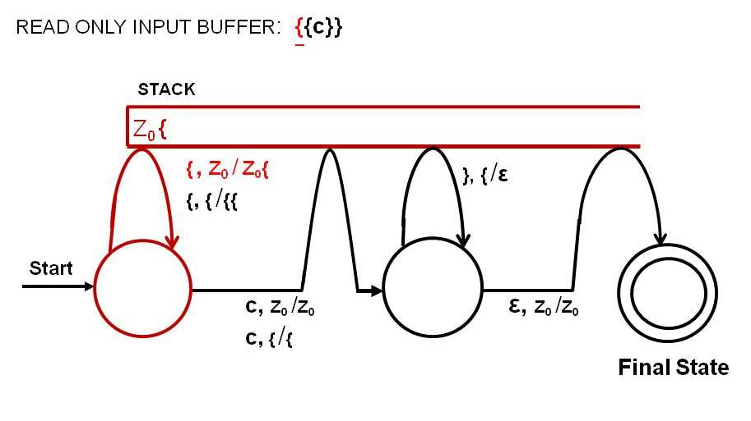
Figure 3: A Pushdown Automaton for L_{m} = { {^{n}c}^{n} : where n >= 0 } when the first input symbol is scanned and a { is pushed into the stack by taking the loop transition labeled {,Z₀/Z₀{.

Then the PDA consumes the 2nd { from the input by taking the loop transition marked by {, { /{{ as shown in figure 4.
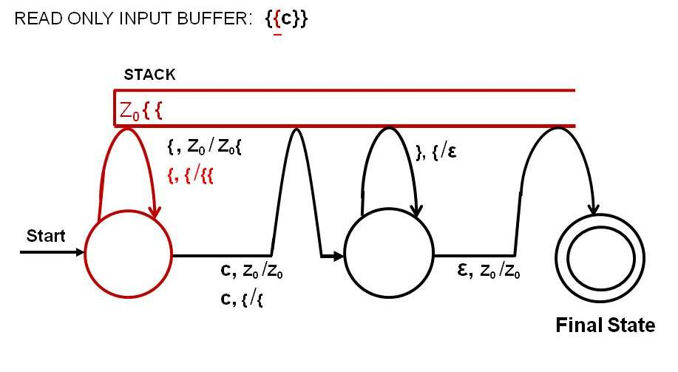
Figure 4: A Pushdown Automaton for L_{m} = { {^{n}c}^{n} : where n >= 0 } when a { is pushed into the stack by taking the loop transition labeled {,{/{{.
Next, the PDA scans the symbol c by taking the transition marked by c, { /{ which means "read a c from the input when there is a { on top of the stack and leave the stack unchanged". This is shown in Figure 5.
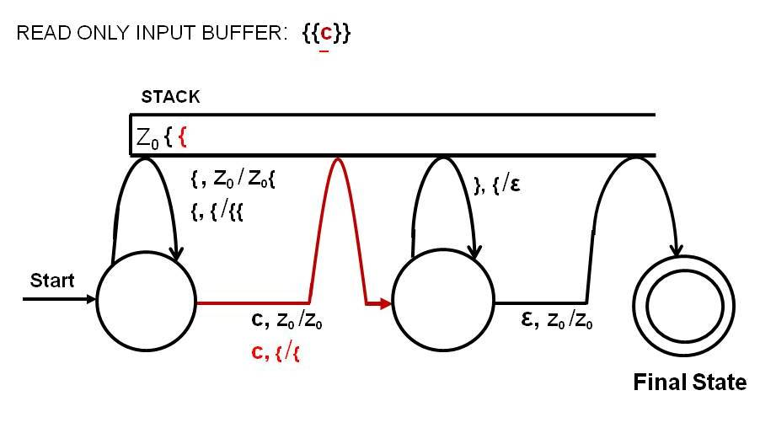
Figure 5: A Pushdown Automaton for L_{m} = { {^{n}c}^{n} : where n >= 0 } when the transition labeled c, {/{ is traversed.
Next, it reads the fourth symbol, } , from the input and pops a } from the stack taking the transition marked by }, { /e as shown in Figure 6.
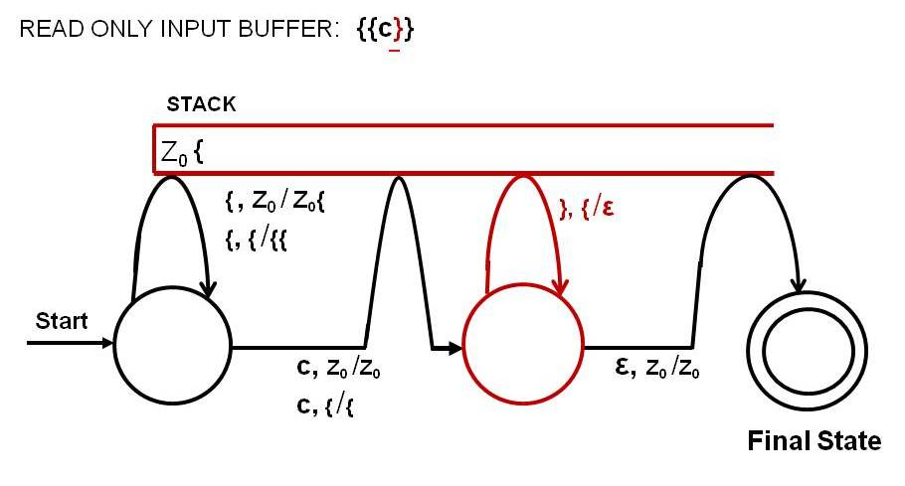

Figure 6: A Pushdown Automaton for L_{m} = { {^{n}c}^{n} : where n >= 0 } when a { is popped from the stack using the loop transition labeled }, {/ε.

Then, it scans the next } by taking the same transition marked by }, { /e again as shown in Figure 7.
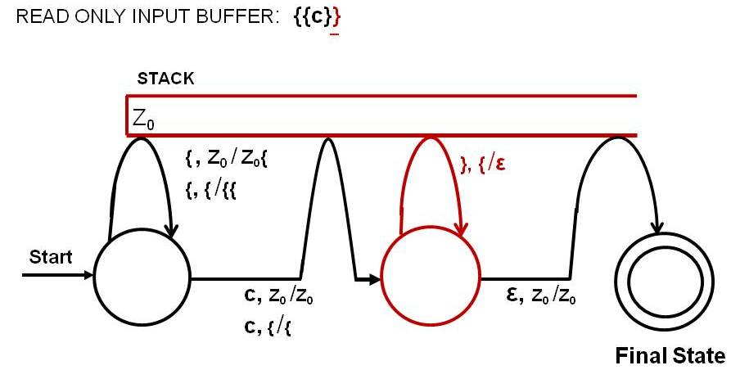

Figure 7: A Pushdown Automaton for L_{m} = { {^{n}c}^{n} : where n >= 0 } when a { is popped from the stack using the loop transition labeled }, {/ε.

Then, it reaches the final state by taking the transition marked e, Z₀ /Z₀ . At that moment stack is empty and the entire input is consumed and therefore the input {{c}} is accepted by the machine.
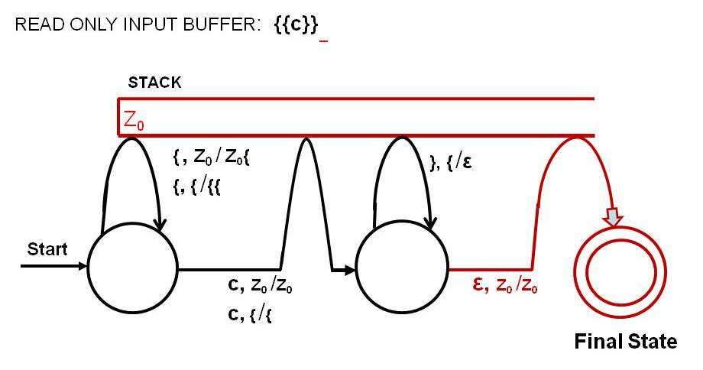

Figure 8: A Pushdown Automaton for L_{m} = { {^{n}c}^{n} : where n >= 0 } when a the machine reaches the final state taking the transition labeled ε, /Z₀/Z₀.

The PDA given above accepts any string with a sequence of {'s followed by a c followed a number of }'s that balances {'s. That is, strings such as c, {c}, {{c}}, {{{c}}}, . . . . are accepted by the machine. An input is accepted by a PDA if all of the following conditions are met simultaneously:
(1) the input is entirely consumed, that is, no other symbols left in the input;
(2) the machine is in a final state;
(3) the stack is empty.

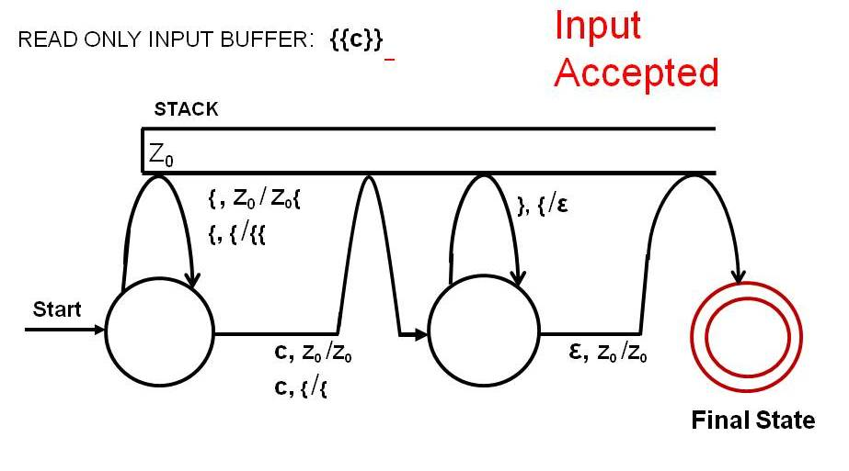
Figure 9: A Pushdown Automaton for L_{m} = { {^{n}c}^{n} : where n >= 0 } when a the machine accepts the input.

